MULTI-LINGUAL SIGN LANGUAGE TO SPEECH
AND SPEECH TO SIGN TRANSLATOR

A Project Report
Submitted in the partial fulfillment of the requirements for the award of the degree of

Master of Computer Applications
In

Department of Computer Science and Applications
By

Uppalapati Naveen Varma

(2401600155)
Under the supervision of
Mrs. Swathi Voddi
Professor
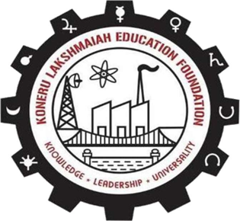

Department of Computer Science and Applications
K L E F, Green Fields,
Vaddeswaram, Guntur, Andhra Pradesh, India- 522502.
2025- 26

KONERU LAKSHMAIAH EDUCATION FOUNDATION

DEPARTMENT OF COMPUTER SCIENCE AND APPLICATIONS
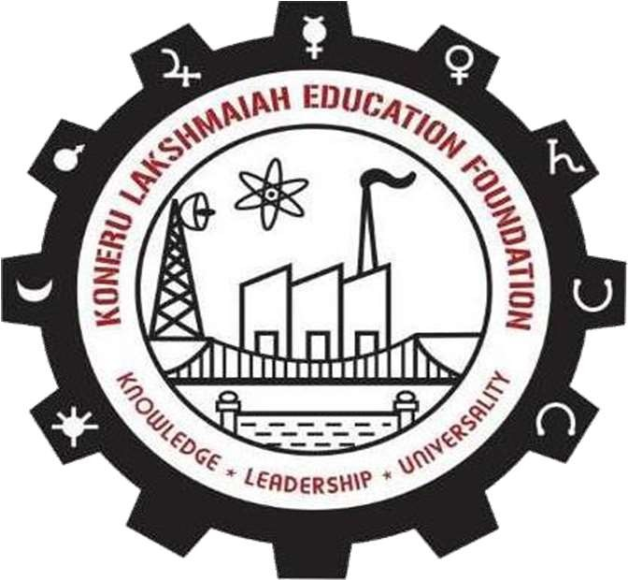

DECLARATION

The Project Report entitled “MULTI-LINGUAL SIGN LANGUAGE TO SPEECH
AND SPEECH TO SIGN TRANSLATOR” is a record of bonafide work of Uppalapati Naveen Varma, submitted in partial fulfillment for the award of Master of Computer Applications in Computer Science and Applications of the K L University. The results embodied in this report have not been copied from any other departments/University/Institute.

Signature of the Student Uppalapati Naveen Varma (2401600155)

KONERU LAKSHMAIAH EDUCATION FOUNDATION DEPARTMENT OF COMPUTER SCIENCE AND APPLICATIONS


CERTIFICATE

This is to certify that the Project Report entitled “MULTI-LINGUAL SIGN LANGUAGE TO SPEECH
AND SPEECH TO SIGN TRANSLATOR” is being submitted by Uppalapati Naveen Varma, in partial fulfillment of the requirements for the award of Master of Computer Applications in Computer Science and Applications to the K L Education Foundation is a record of bonafide work carried out under our guidance and supervision. The results embodied in this report have not been copied from any other departments/ University/ Institute.

Signature of the Supervisor Signature of the HOD

(Dr. R.D. Sathiya) (Dr. G. Krishana Mohan) Professor Professor & HOD

Signature of the Examiner

ACKNOWLEDGEMENT

The satisfaction that accompanies the successful completion of any task would be incomplete without the mention of people who made it possible and whose constant guidance and encouragements crown all the efforts with success.

I am very thankful to our project guide Dr. R D Sathiya, Professor for her continuous support and encouragement in completing the Project work. Without her help the project couldn’t have been completed.

I express our heartful gratitude to Dr. G. Krishna Mohan, Head of the Department of Computer Science and Applications for providing us with adequate facilities, ways and means by which we are able to complete this project.

I express our heartful gratitude to Dr. K Subrahmanyam, Professor and Principal College of Sciences, for providing us with adequate facilities, ways and means by which we can complete this project.

Last but not the least, we thank all Teaching and Non-Teaching Staff of our department and especially my classmates and my friends for their support in the completion of our project.

Signature of the Student

Uppalapati Naveen Varma

(2401600155)

